Peter Albert Stevens Sly
3rd November 1929- 9th March 2015
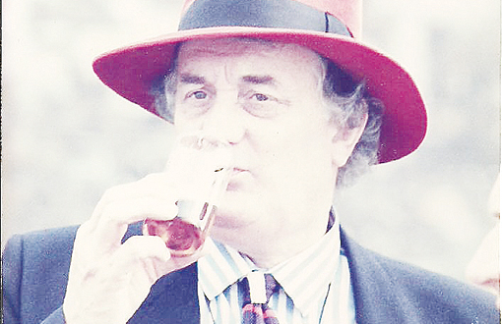
(Pat Sly and Anthony West have very kindly given us permission to include Anthony’s Eulogy from Peter’s funeral held at St Nicholas Church, Remenham on 26th March 2015.)
Sarah and I moved to Remenham in 1969 and the first eight years were fairly uneventful, save for bringing up our children. However, from 1977 that was all to change when Peter arrived on the scene, having bought Old Blades, previously only viewed from the outside, but Pat, nevertheless, moved with Peter and, in her own right, has been a tower of strength in the Village.
Almost immediately, Peter made his presence felt and became the Mr Fixit of the Village. If anything needed to be done, Peter was the first man to ask, although it was always necessary to involve Pat to ensure that it was done in the right place and at the right time.
Every Village has its Institutions and Peter involved himself with all of them, apart, possibly from the Womens Institute, where he was disqualified from active participation. In his turn, and often concurrently, Peter served on the Parish Council, the Parochial Church Council, the Parish Hall Committee, as Churchwarden (and, latterly, as Churchwarden Emeritus), the Remenham Fayre and, of course, the Remenham Thespians. In all these offices, Peter acted with enormous energy and enthusiasm, even if, on occasions, with a lack of political correctness, not a concept which much interested him, he being of the old school of calling a spade a ‘something’ shovel.
In Church matters, Peter organised the Memorial to John Hunt, made of Welsh slate, which is now in place on the north wall of this Church. Whether the Welsh slate manufacturers or the diocesan authorities (in the matter of a faculty) gave Peter the more aggravation, it is hard to tell, but he was typically (and volubly) critical of each.
The Parish Hall, under Peter’s Chairmanship, has gone from strength to strength, and now boasts a state of the art kitchen, suitable for community events, including Quiz Nights, the first of which, with Peter’s input, took place in 1994.
The annual Remenham Fayre, and other Parish Hall events, were often masterminded by Peter, particularly in giving apposite advice, usually in the vernacular, to those volunteers toiling to erect the most bad tempered marquee that money could have bought. On the day of the Fayre, Peter’s particular skill (apart from endless encouragement to the tug of war teams) was in organizing the children’s races. I am sure that Peter never obtained a CRB check, as remarks like “You stupid child, you put your feet in the sack, not the sack over your head” were quite the norm and all the children took it entirely in their stride. The same was true about the Mini Thespians.
I suppose that it is with the Thespians that Peter really shone. Started in 1992, with a play called “What do you expect for One pound fifty?!” Peter was, from the outset, the self -appointed Director. Corralling many villagers to participate, several against their will, and all against their better judgement, Peter kept the show on the road despite his appalling rudeness to members of the cast (“Come on, I know you can’t act, but at least let us hear the words”). On occasions, Peter, himself, took an acting role, although, latterly, it was important to have a set with many flat surfaces, so that his lines, and, more importantly, his cues, could be written on post it slips around the stage. Peter usually introduced the production and almost invariably used words such as “I can’t think why you are all here, as this will almost certainly be the worst play you have ever seen, but please be tolerant as the actors are trying their rather poor best!”
The Flower Pot in Aston was much frequented by Peter and, typically, when Fred retired and was unable to look after himself, Peter and Pat took him in and cared for him. Similarly with Teddy Selwyn, on whom for several years, Peter kept a particularly watchful eye. In fact Peter, despite his sometimes bluff exterior, had a heart of gold and could always be relied upon to offer support to anyone in need. He and Pat made the garden of Old Blades available for various charity fund raising events.
A mnemonic of the word Remenham suitable for Peter’s memory might read:
Rumbunctious, Energetic, Munificient, Eccentric, Newsworthy, Hospitable, Adaptable, Memorable.
Our sympathy goes out to Pat, Peter’s staunch, and constant, support, and to Oscar, Prudence and their families; Peter will be sorely missed by us all, but how good to have known him.

