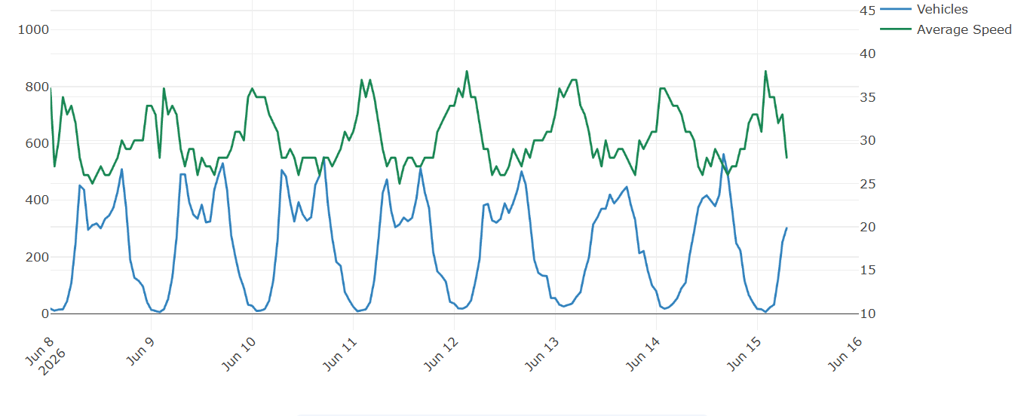
9-16 June 2026
Maximum speed 62.5mph
41178 vehicles in total
30mph section of A4130 facing HoT

