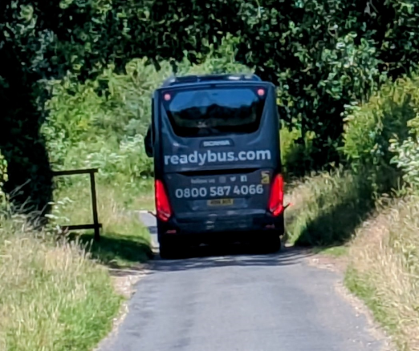
Bus-coach on RCL on 13th June 2026 met by pedestrian

