All 2026 Remenham traffic data
A4130

A4130 30mph section facing HoT 29th June-6th July 2026 (HRR)
Maximum speed 67.5mph
Total Vehicles 57569
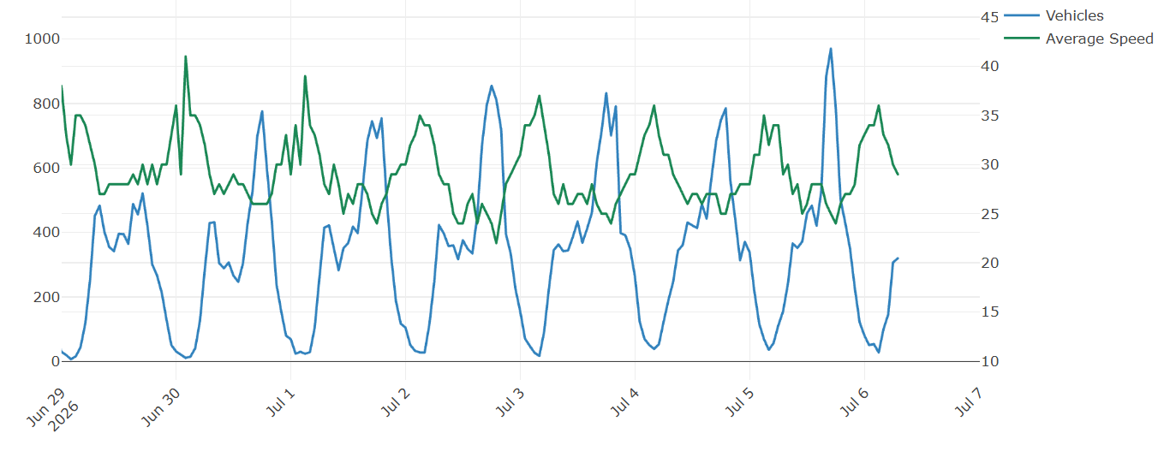
A4130 30mph section facing HoT 6-14th July 2026 (HF-HMR)
Maximum Speed: 62.5 mph
Total Vehicles: 46335
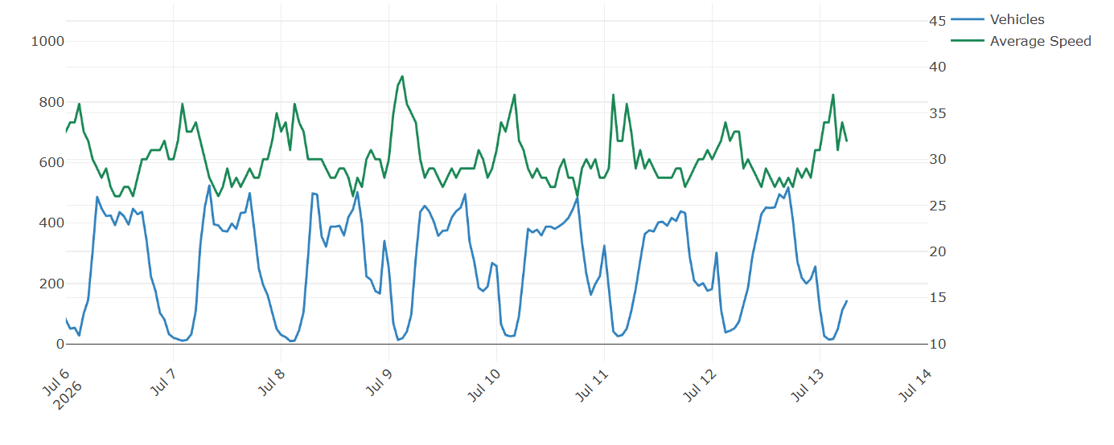

A4130 30mph section facing HoT 13-20th July 2026 (HF and HMR)
38385 vehicles. Max speed 63mph
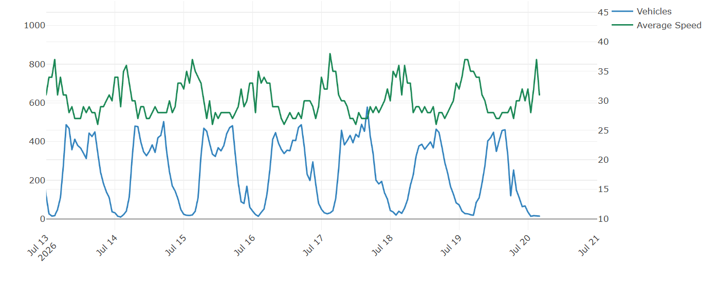

A4130 30mph section of facing HoT 10-17th August 2026 (no events)
Maximum Speed: 67.5 mph
Total Vehicles: 39802

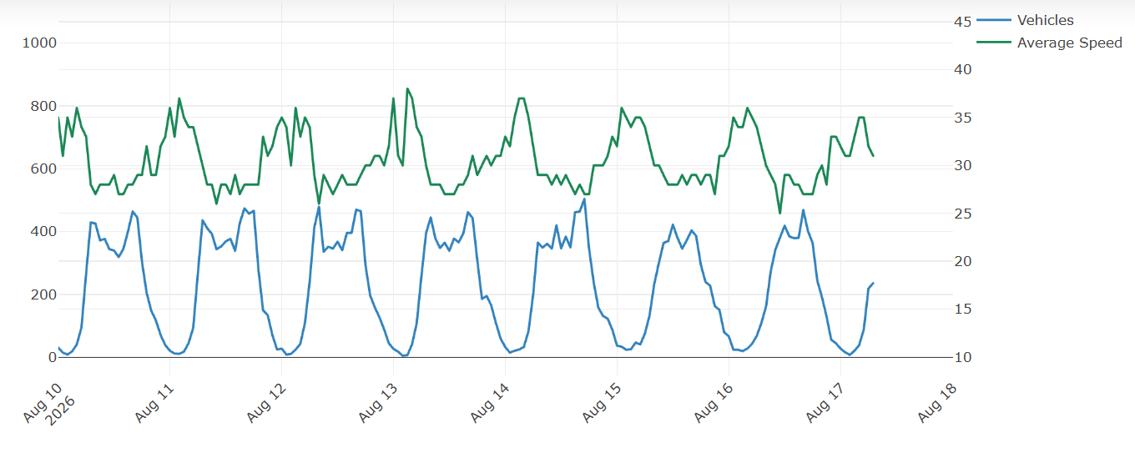

A4130 30mph section facing HoT 19th-27th August 2026 (RewindS)
Maximum speed 72.5mph
Total Vehicles 43087 (doubling vehicles number/hour after RewindS)
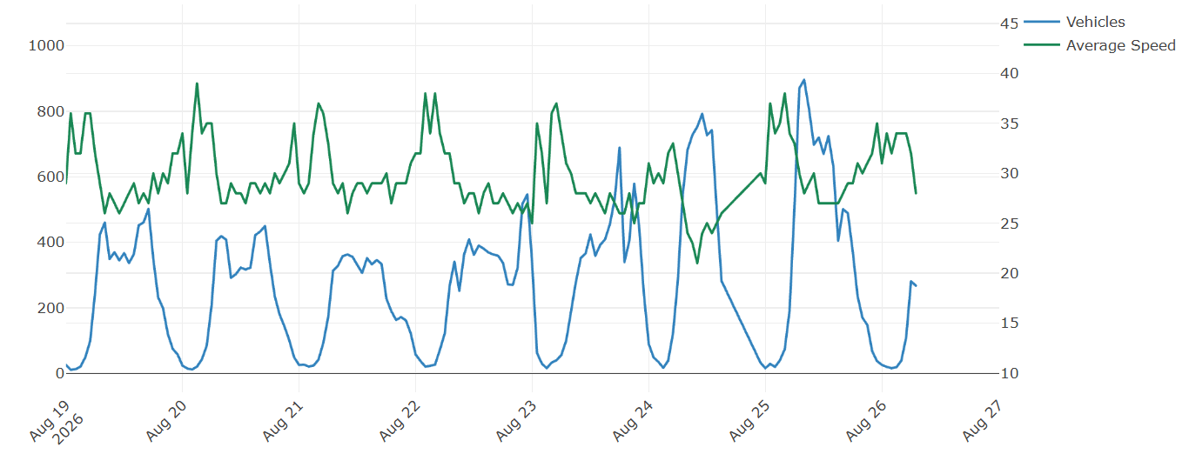

A4130 30mph section facing HoT 3rd Aug- 2nd Sept 2026 (RewindS)
Maximum speed 82.5mph
Total Vehicles 174166
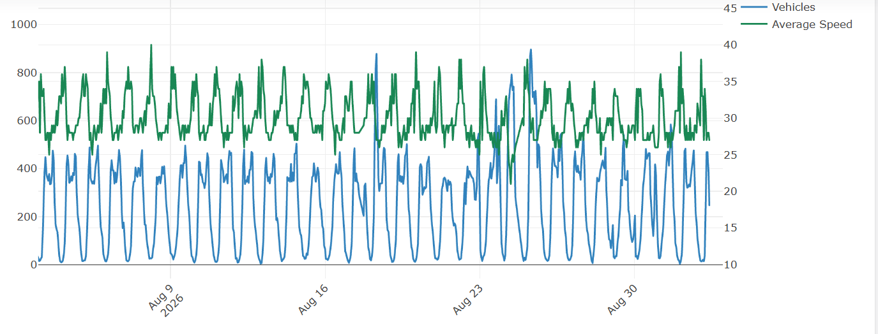

RCL

RCL 16-18th June 2026 (No events)
Max speed 38.5mph.
Two way.
19 vehicles/hour on average (max 82 per hour)
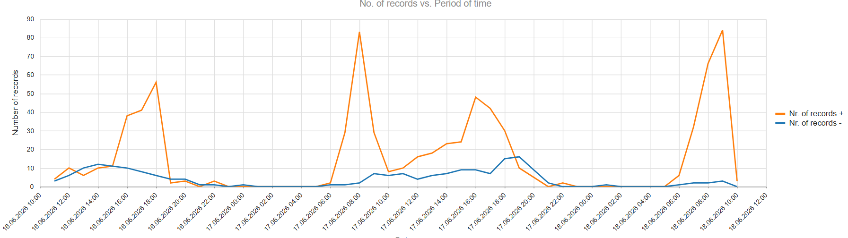

RCL 20th -22nd June 2026 (HWR)
Max speed 44mph
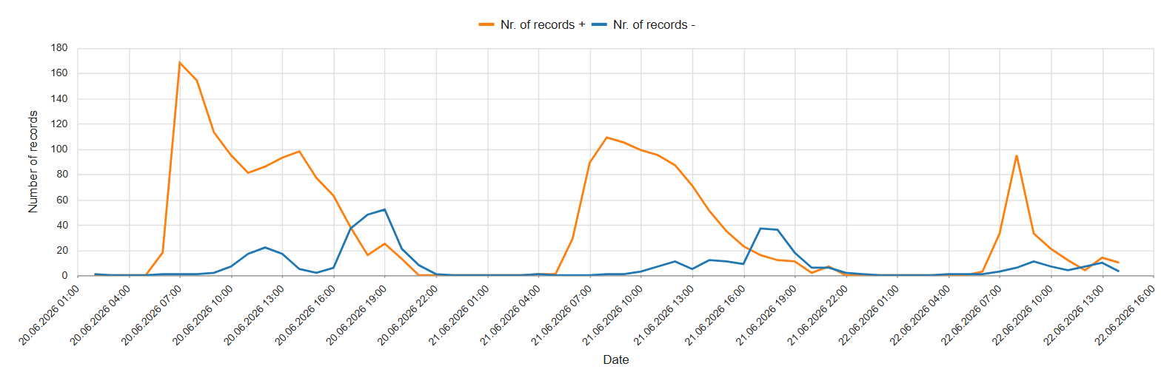

RCL 22-29th June 2026 (no events – Henley swim classic?)
Maximum speed 44mph
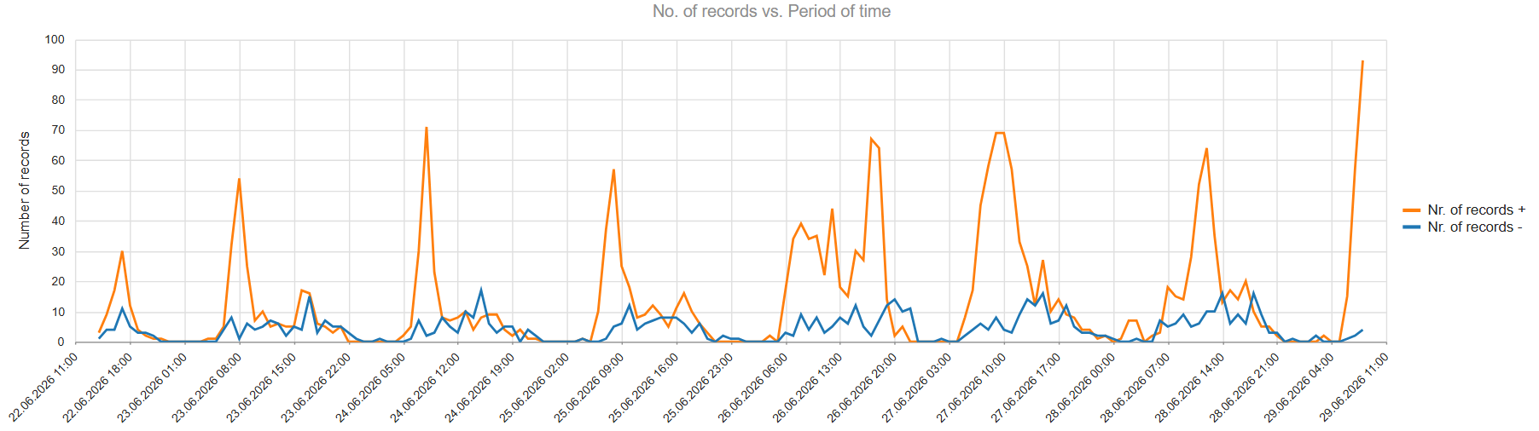

RCL 29th June-3rd July (HRR).
Max speed 53mph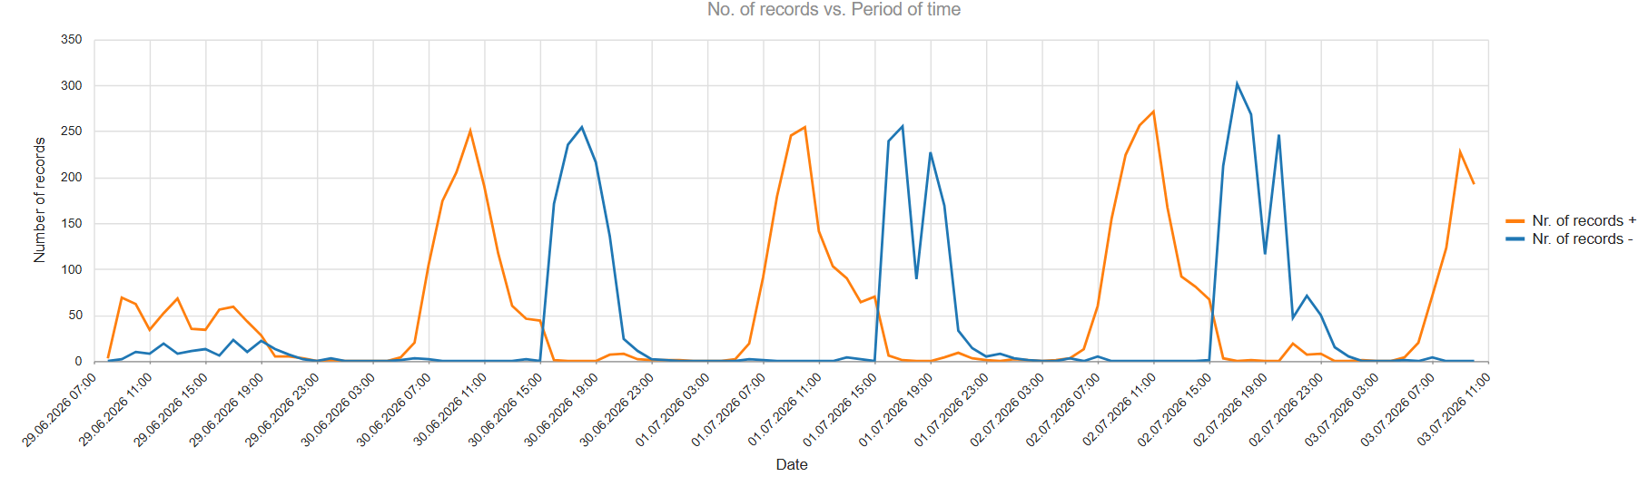

RCL 3-6th July 2026 (HRR).
Maximum speed 54mph
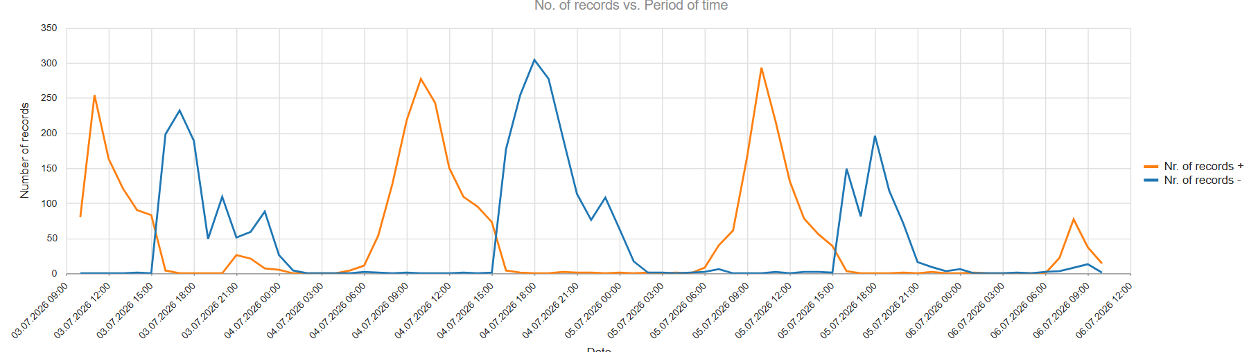

RCL 6th-20th July 2026 (Henley Festival & Henley Masters)
Max speed 74 mph
6347 (4121+/2226-)
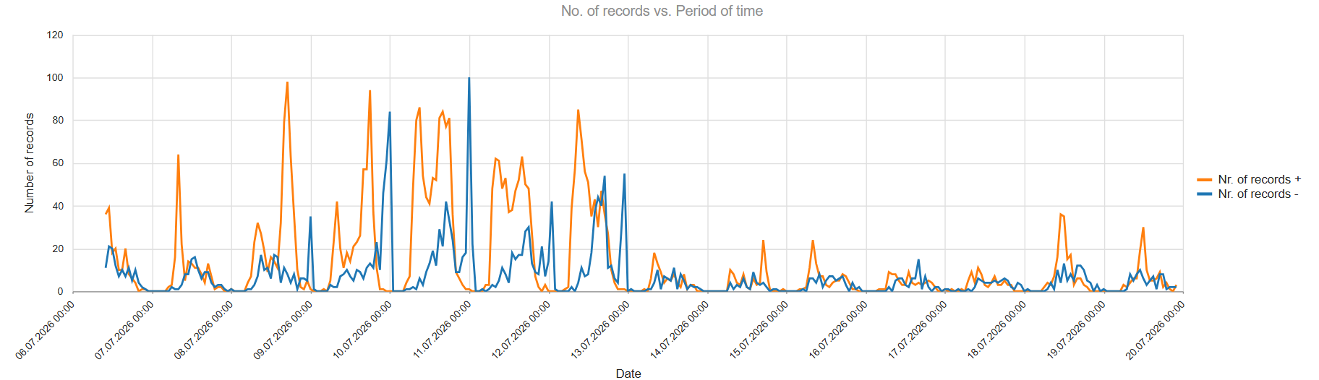

RCL 17th August -2nd Sept 2026 (including Rewind South)
Max speed 67 mph (+ towards church) 43 mph (- away from church)
11987 (7289+/4698-)
Vehicles per hour plotted
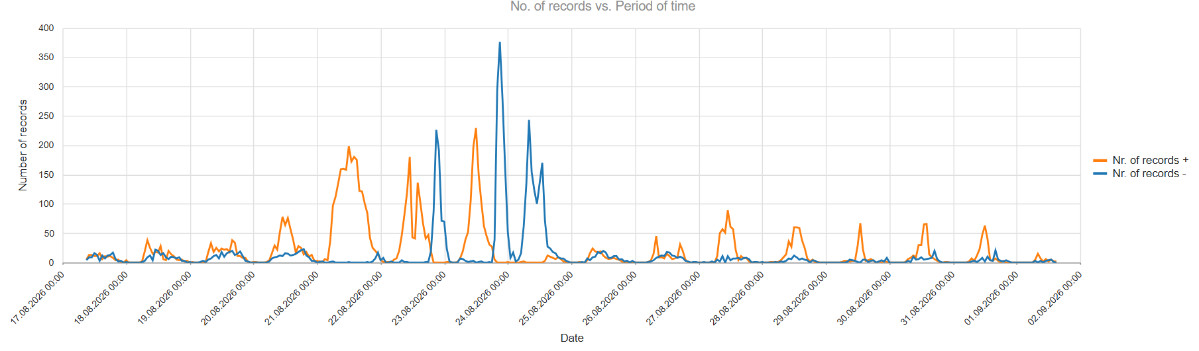

AL
AL 16-18th June 2026 (no events)
Max speed 49mph
660 vehicles (332 +; 328 -); average 20-25 vehicles/hour
Two way. 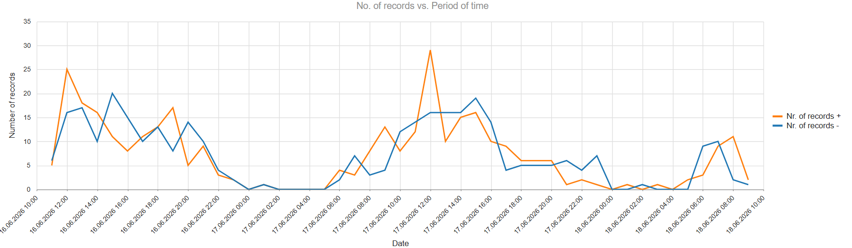

AL 18th-26th June 2026 (HWR)
Max speed 49mph
3698 vehicles (1709+; 1989-); upper range 25-30 vehicles/hour
Two way.
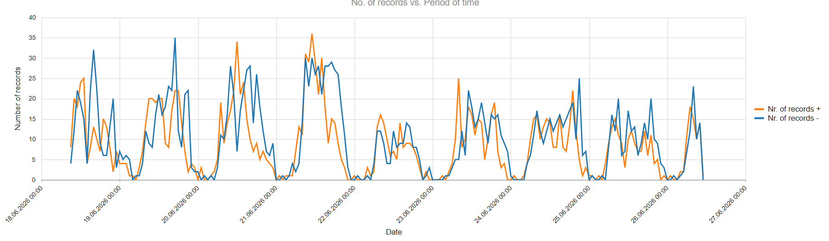

AL 26th-29th June 2026 (no events)
Max speed 39mph + and 45mph –
1424 vehicles (676+; 748-); upper range 25-30 vehicles/hour
Two way.
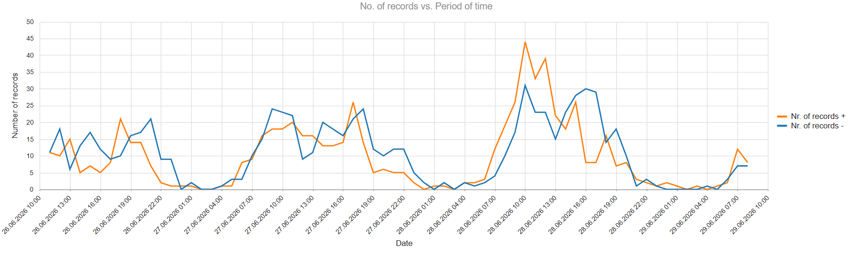

AL 29th June-3rd July 2026 (HRR)
Max speed 50mph + and 42mph –
2002 vehicles (1079+; 923-); upper range 40-51 vehicles/hour
Two way.
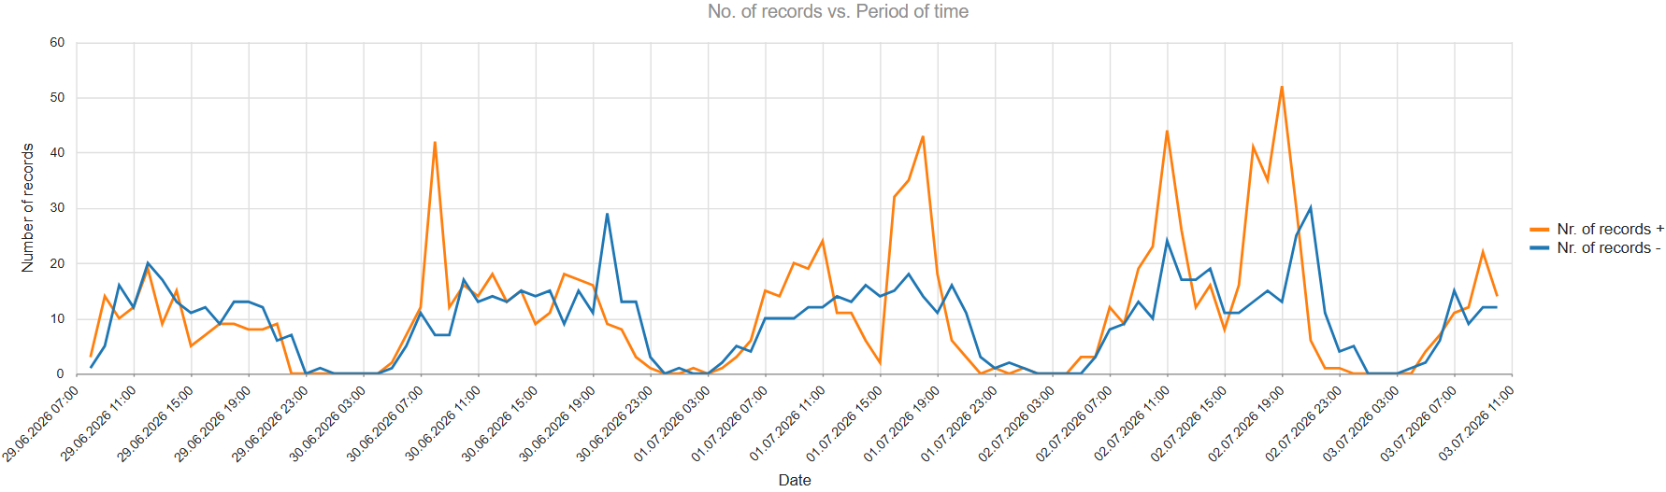

AL 3rd-6th July 2026 (HRR)
Max speed 52mph + and 41mph –
1665 vehicles (810+; 855-); upper range 48 vehicles/hour
Two way.
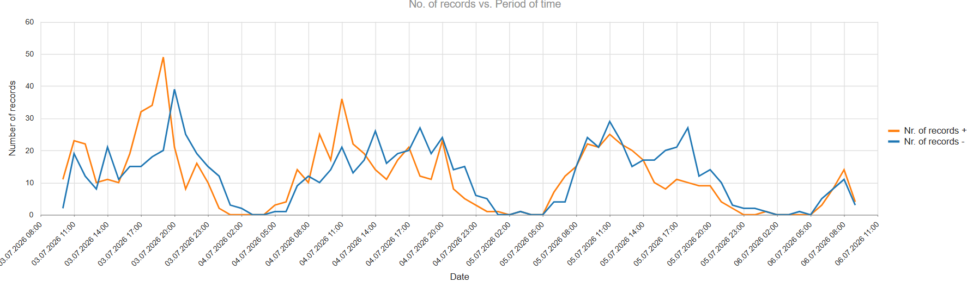

AL 6th-13th July 2026 (HF & HMR)
Max speed 39mph + and 40mph –
2995 vehicles (1295+; 1700-); upper range 35-40vehicles/hour
Two way.
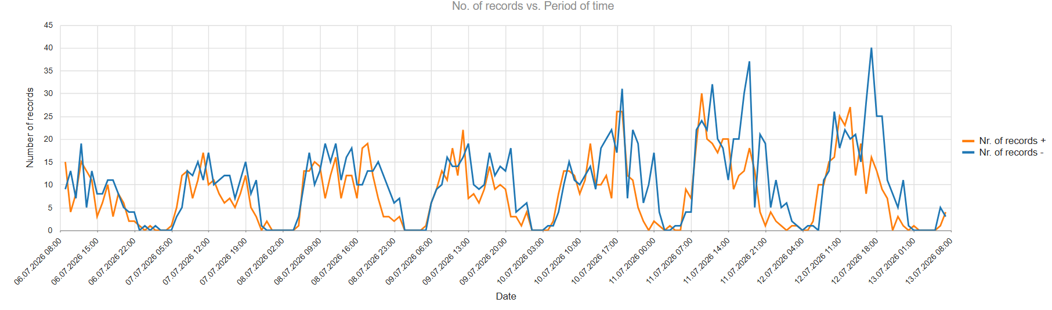

AL 13-14th July 2026 (no events)
Max speed 40mph + and 39mph –
478 vehicles (234+; 244-); upper range 19/20vehicles/hour
Two way.
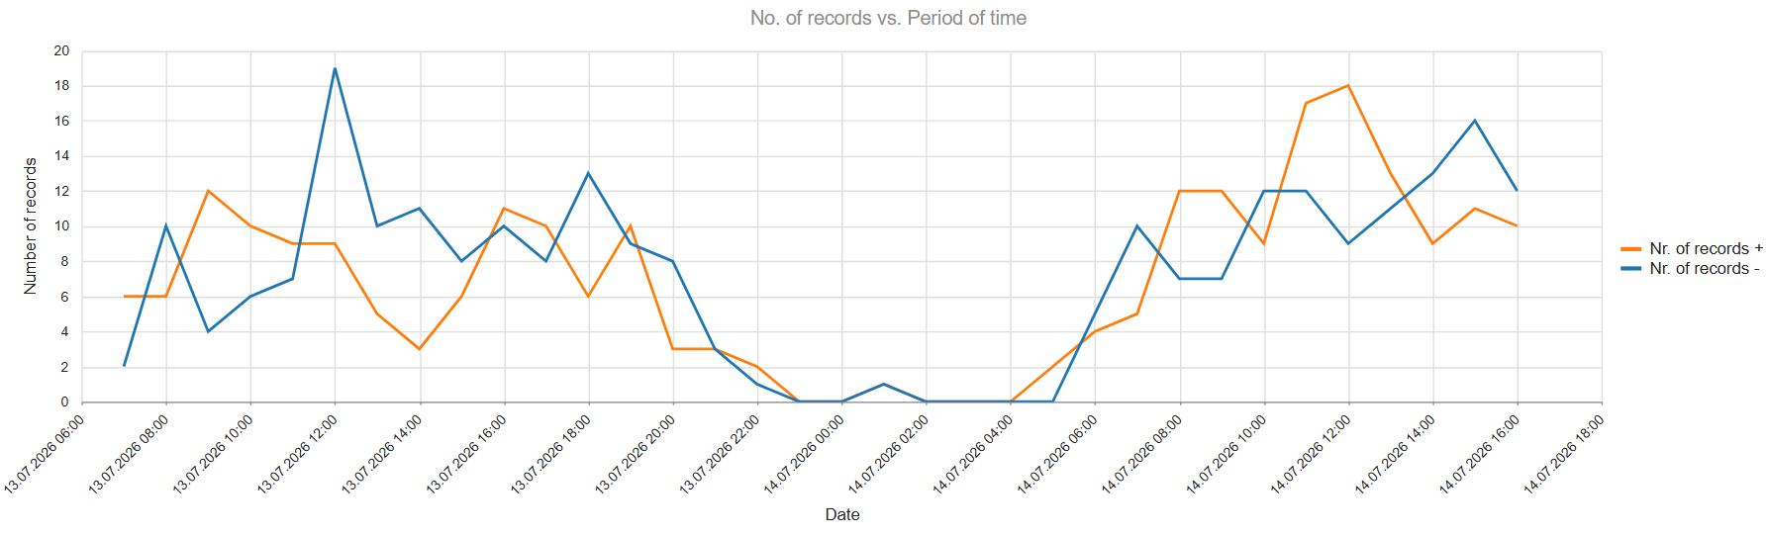

AL 20th July-19th August 2026 (no events)
Max speed 44mph + and 59mph –
12579 vehicles (5818+; 6761-); upper range 35-40vehicles/hour
Two way. Heavist traffic levels on a Sunday?
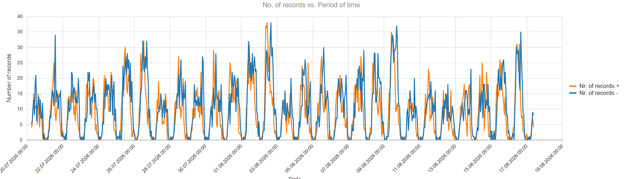

AL 20th July-19th August 2026 (no events)
Max speed 44mph + and 59mph –
12579 vehicles (5818+; 6761-); upper range 35-40vehicles/hour
Two way. Small increase in traffic levels on 23rd-24th August
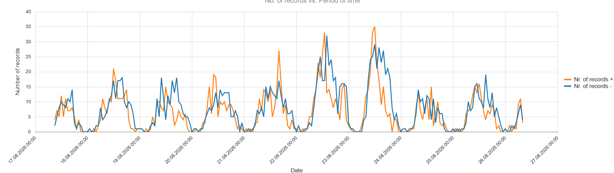

AL 17-26th August 2026 (Rewind South)
Max speed 39mph + and 52mph –
3017 vehicles (1384+; 1633-); upper range 30-40vehicles/hour
Two way.

